**Pacific Atlantic Water Flow:**

You are given an m x n integer matrix heights representing the height of each unit cell in a continent. The **Pacific ocean** touches the continent's left and top edges, and the A**tlantic ocean** touches the continent's right and bottom edges.

Water can only flow in four directions: up, down, left, and right. Water flows from a cell to an adjacent one with an equal or lower height.

Return *a list of grid coordinates where water can flow to both the Pacific and Atlantic oceans*.

**Example 1:**

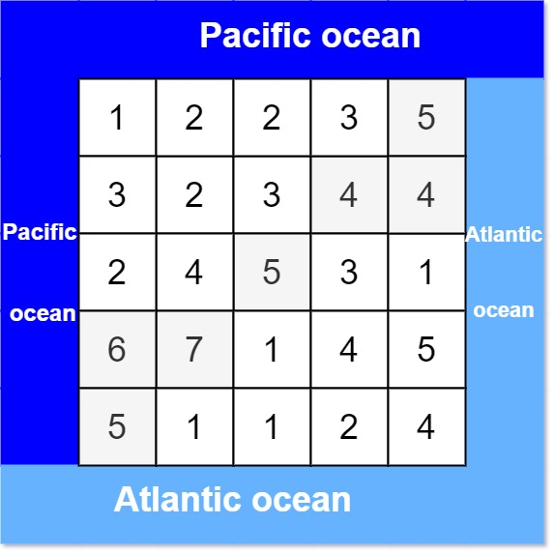

**Input:** heights = [[1,2,2,3,5],[3,2,3,4,4],[2,4,5,3,1],[6,7,1,4,5],[5,1,1,2,4]]

**Output:** [[0,4],[1,3],[1,4],[2,2],[3,0],[3,1],[4,0]]

**Example 2:**

**Input:** heights = [[2,1],[1,2]]

**Output:** [[0,0],[0,1],[1,0],[1,1]]

**Constraints:**

* m == heights.length
* n == heights[i].length
* 1 <= m, n <= 200
* 0 <= heights[i][j] <= 105

s